Guidelines for schools on maintaining hygiene during COVID-19

By DBE

Date: 01/05/2020
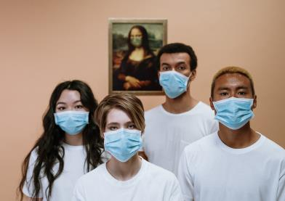
IMPLEMENTING EXTRAORDINARY/ DRASTIC MEASURES AGAINST COVID -19

Guidelines for schools on maintaining hygiene during the COVID-19 pandemic
PURPOSE
These guidelines provide recommendations on the essential cleaning and use of Personal Protective Equipment (PPE) based on risk exposure for schools against exposure to the COVID-19.
COVID-19 is spread by fluid droplets when coughing, sneezing or shouting and can be spread by a person who has been infected before symptoms occur, during illness and for a short period of time after they feel better. Researchers estimate that around 44% of infections are passed-on by people who are not showing any symptoms.
Virus particles can survive in the air for a short period of time and can remain on hard surfaces such as plastic or steel for a few days, if not removed with regular cleaning. COVID-19 is spread by contaminated hands touching the hands of others and touching things such as money, credit cards, door handles and counters. When you then touch your eyes, nose and mouth after you have touched other people’s hands and things with COVID-19 on it, then you can get infected.
- PRINCIPLES OF INFECTION PREVENTION AND CONTROL
A safe environment can be achieved through elimination of infectious particles in the air and on surfaces by always adhering to the Golden Rules:
- RISK REDUCTION METHODS FOR CLASSROOMS/OFFICES
Each classroom must have access to:
- Prevent direct contact with persons that are sick. Educators and learners are requested to only attend school if healthy. Kindly follow the Guidelines for the containment/management of COVID-19 for childcare facilities, schools and school communities in this regard.
- Control measures include personal protective equipment (PPE) and risk reduction methods as discussed below, e.g. cleaning surfaces with disinfectant to kill the virus.
- Keep a distance of 1m between persons in any circumstance.
- Wash hands with soap and water for 20 seconds, or use alcohol-based hand sanitiser after contact with any person or after contact with frequently touched surfaces i.e. phones, door handles etc.
- Avoid touching your eyes, mouth, or nose with unwashed hands.
- Airborne transmission should be limited by allowing ventilation in classrooms.
- Cough in the fold of the bent elbow and sneeze in a tissue which you discard and wash your hands.
- Surfaces that are frequently touched, e.g. toilet door handles, etc, should be cleaned with diluted bleach disinfectant (20 ml bleach per litre water) hourly, or less frequently depending on the circumstance.
- Avoid places where crowding exists.
- Comply with the National Lockdown rules.
- RISK REDUCTION METHODS FOR SCHOOLS
- Each person (parent, teacher, learner or visitor) that enters or leave a school must wash hands or sanitise their hands at the entrance/gate utilizing hand hygiene stations, equipped with soap (bar or liquid) and water or sanitise (with 70 % alcohol base).
- Take the temperature of each person (parent, teacher, learner or visitor) that enters a school with a Digital thermometer scanner as follows:
  - Remove the protective scanner cap
  - Switch it on and wait for ‘00’ reading
  - Scan the forehead
  - A reading of 37.5 and above indicate possible fever
  - Visitors and staff with a fever are not allowed on the school grounds
  - Learners with a fever must to be kept separate from others until they can return home. Parents/caregivers should be contacted without undue delay
- The installation, supervision, and regular refilling of the stock / equipment is the responsibility of the principal, delegated to the factotum / cleaners.
- Principals must ensure:
  - The rapid procurement / delivery of adequate quantities of products in the Basic and Essential Sanitation and Hygiene Package for Each School by timely ordering and filling up on stock.
  - Ensure refresher hand hygiene training and reminders to learners
  - Communication to parents about the importance of hand hygiene in preventing the spread of the COVID-19 virus.
Some examples of handwashing stations 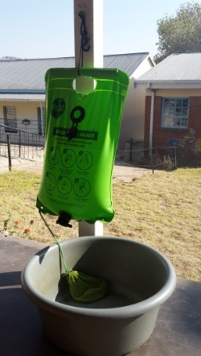
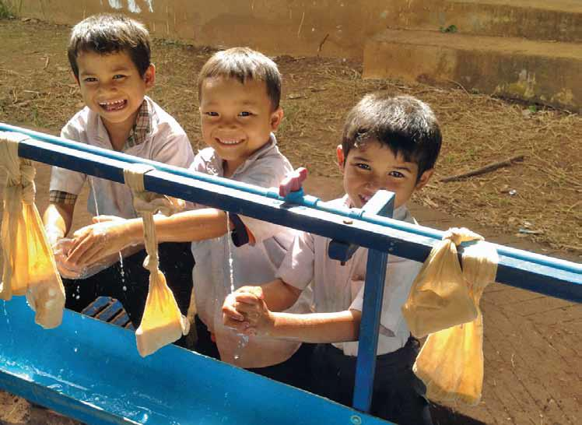
- A portable handwashing station, handwashing soap (bar or liquid) or hand sanitizer with at least 60 % alcohol base
- A litter bin with lid, lined with a bin liner in which all tissues, paper towels and possible contaminated waste must be discarded
- Paper towels to dry hands or wipe surfaces. Used paper towels must be discarded safely in the litter bin with a lid.
- Face masks[1] (cloth masks) and/or visors
Note: N95 masks are reserved for use by clinicians treating or looking after COVID-19 suspected or positive patients
- Advocacy material on handwashing must be available. Information messages should also include:
  - Avoid touching eyes, nose and mouth.
  - Follow good respiratory hygiene: covering your mouth and nose with your bent elbow or tissue when coughing or sneezing, then dispose of the used tissue in a bin with a lid.
  - Maintain at least one and a half meter distance between yourself and others.
Hand Hygiene Procedures:
- Frequent hand hygiene must be part of the routine of everyday life in schools. Every person that enters a classroom must wash their hands with soap (bar or liquid) and water or sanitise (with at least 60 % alcohol base) their hands and again when leaving the classroom.
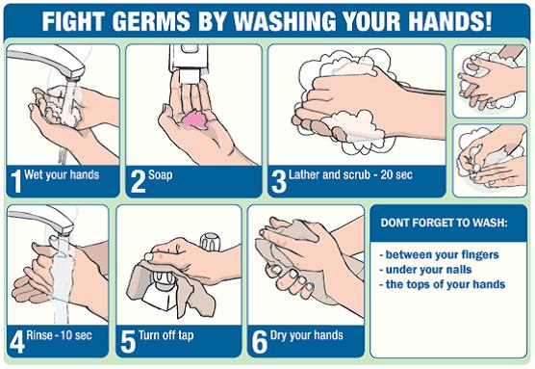
- Surfaces that are frequently touched, e.g. the doorknobs, must be cleaned hourly with a 20 ml bleach per litre water, or disinfectant wipes.
- Utensils like pens and pencils must not be shared amongst learners or teachers. .
- Classrooms must be well ventilated. Coughing (in the bent elbow) and sneezing etiquette (in a tissue) must be adhered to.
- Social distance of 1.5m must be adhered to at all times.
- Classrooms must be cleaned at least twice a day with a disinfectant.
- RISK REDUCTION FOR EACH TOILET/BATHROOM
A portable handwashing station, handwashing soap (bar or liquid) or hand sanitizer with at least 60% alcohol base should be within 5m of toilets, for handwashing after using the toilet.
Disinfectant cleaner (Recommend sodium hypochlorite 0.5% (biocide sachets) or Bleach mixture of 250ml of bleach to 5 litres of water) must be utilised for daily cleaning of all surfaces.
Surfaces that are regularly touched, e.g. taps, doorknobs and toilet handles must be wiped down hourly with 20 ml bleach per liter water or disinfectant wipes.
- FOOD PREPARATION AREAS (SCHOOLS WITH NSNP)
Volunteer Food Handlers must wash their hands thoroughly before preparing food. Head gear, face masks and disposable plastic aprons must be worn to prevent droplet transmission.
All surfaces must be cleaned daily with Disinfectant cleaner (recommend sodium hypochlorite 0.5% (biocide sachets) or Bleach mixture of 250ml of bleach to 5 litres of water).
Surfaces must be cleaned with at least 60% ethyl alcohol cleaner for wiping down in-between daily cleaning.
- DAILY DUTIES OF CLEANERS
Daily duties of cleaners include:
- Clean all surfaces e.g. floors, bathrooms desks daily with Disinfectant cleaner (recommend sodium hypochlorite 0.5% (biocide sachets) or Bleach mixture of 250ml of bleach to 5 litres of water).
- Surfaces that are frequently touched, e.g. taps, doorknobs at classrooms and toilets, toilet flush, must be cleaned hourly with 20 ml bleach per liter water.
- Collect all the bags with possible contaminated waste in bins in classrooms and offices. Ty the bags and put it in big refuse bags. Ty the refuse bags again.
- Wear protective gear as discussed below.
- PERSONAL PROTECTIVE EQUIPMENT (PPE) FOR CLEANING
PPE usage is based on the risk assessment of each situation and is ONLY NEEDED where staff are exposed to or the occupation that poses risk of exposure to COVID -19 infected individuals. PPE is classified into categories: eye and face protection (goggles, visor, plastic shields), hand protection (various types of gloves), body protection (apron, coats) and respiratory protection (depending on risk – various types of masks). All education officials and visitors must adhere to The Golden Rules of Hygiene as discussed above.
In addition, it is recommended that cleaners should have access to:
- Heavy duty gloves
- Face masks
- Disposable plastic aprons
- Protective eye gear
- Closed shoes
Correct use, necessary hygiene practices and proper disposal of PPE is important to avoid cross contamination from PPE to the user’s hands or clothes. Cleaners should perform hand hygiene using the proper techniques before putting on protective gear for cleaning and after removing it, when changing gloves or after any contact with waste material.
The procedure to put on protective gear (see left side of picture below):
- Wash hands with soap and water
- Put on the plastic apron
- Put on the face mask
- Put on the eye protection
- Put on the gloves
The procedure to take off protective gear (see right side of picture below):
- Wash the gloves with disinfectant and dry with a paper towel. Place the paper towel in a bin.
- Remove the gloves and put it on a disinfected surface.
- Remove the eye protection.
- Remove the plastic apron and place it in a bin with a liner.
Remove the face mask and place it in a bin with a lid and bin liner (plastic bags).
- Wash your hands with soap and water.
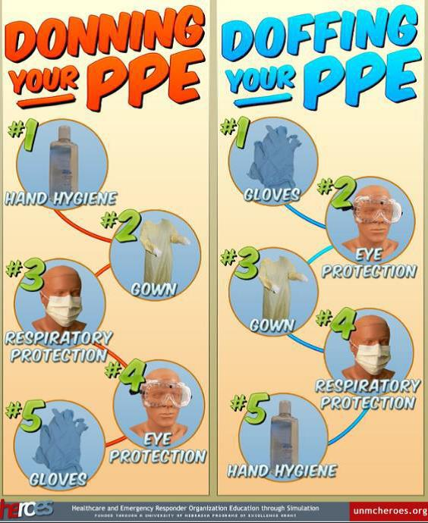
HOW TO PUT ON, USE, TAKE OFF AND DISPOSE OF A MASK

Note: Masks are only effective when used in combination with the other Golden Rules of prevention listed above.
Cloth masks need to be washed with warm soapy water and dried in the sunlight and/or ironed.
- Before touching the mask, clean hands with an alcohol-based hand rub or soap and water.
- Take the mask and inspect it for tears or holes.
- Orient which side is the top side (where the metal strip is).
- Ensure the proper side of the mask faces outwards (the coloured side).
- Place the mask to your face. Pinch the metal strip or stiff edge of the mask so it moulds to the shape of your nose.
- Pull down the mask’s bottom so it covers your mouth and your chin.
- After use, take off the mask by removing the elastic loops from behind the ears while keeping the mask away from your face and clothes, to avoid touching potentially contaminated surfaces of the mask.
- Discard the mask in a closed bin immediately after use.
- Perform hand hygiene after touching or discarding the mask – Use alcohol-based hand rub or wash your hands with soap and water.

I. LEARNER TRANSPORT
All commuter transport services including passenger bus services, taxi services, and private cars transporting learners to school must adhere to the Regulations issued in terms of Disaster Management Act 2002 (Act no 57 of 2002) and all directives set out in the schedule to address and contain the spread of COVID-19 including:
Loading capacity of learner transport: Regulation 11C as amended by the substitution Regulation by a; b and c below:
(a) All Minibuses must reduce seating capacity by capacity to mitigate the spread of the virus.
(b) Bus services, taxi services and e- hailing services shall not carry more than 50% of the licensed capacity; and
(c) Private vehicles shall not carry more than 60% of the licensed capacity, and that all directions in respect of hygienic conditions and the limitation of exposure of persons to COVID -19, are adhered to.
Provision of improved access and hygiene, disinfection control on learner transport.
All operators of learner transport facilities must on regular intervals provide adequate sanitisers or other hygiene dispenser for washing of hands and disinfection equipment for learners.
Embarkation of learners in the vehicles
- All operators must ensure that public transport vehicles are sanitised before picking up and after dropping off learners.
- Operators must ensure that all learner transport vehicles door and window handles, armrest and handrails are sanitised before picking up and dropping off learners.
- Operators must ensure that all learner transport vehicles are clean and tidy.
- All learner transport operators must provide disinfection information materials and procedures.
- All drivers and learners must wear a mask.
- The sanitisers used to sanitise all learner transport vehicles must have a minimum of 60% alcohol content.

